Tutorial 5 – Defect Reporting
Screenshot Report
Field | Details
Website / Tool | SauceDemo
URL | https://www.saucedemo.com
Module | Login, Inventory, Cart, Checkout
Student Task | Test the shopping application, execute 10 test cases and report ONLY the defects you actually observe.
Test Cases | Same TC IDs as the test case sheet: TC01 to TC10
Tester Name | Tester: Kothari Mann Jitendrakumar
Enrollment No | 2504030100433
Environment | Windows 10/11, Google Chrome (latest), internet connection

Test Case Execution

TC01 – Verify login with valid credentials
TC ID | TC01
Test Case | Verify login with valid credentials
Test Data | standard_user / secret_sauce
Expected Result | Products page opens
Actual Result | Products page opened
Status | PASS
Screenshot | 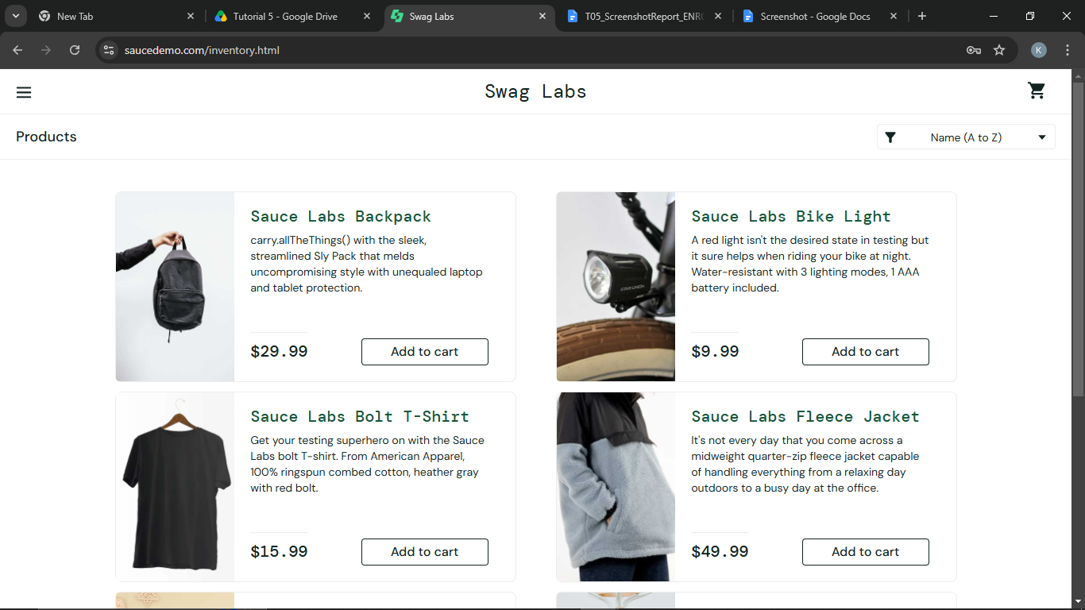.
Defect ID

TC02 – Verify login with invalid credentials
TC ID | TC02
Test Case | Verify login with invalid credentials
Test Data | standard_user / wrong_pass
Expected Result | Error 'Epic sadface: Username and password do not match any user in this service' is displayed
Actual Result | Error message displayed
Status | PASS
Screenshot | 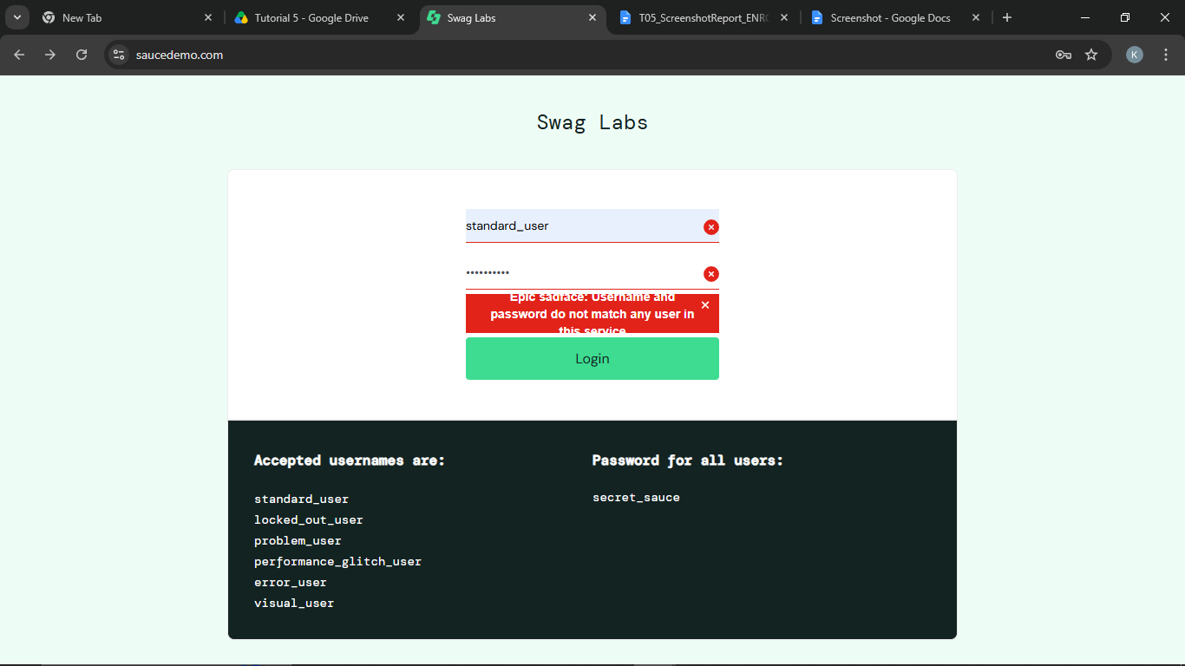
Defect ID | N/A

TC03 – Verify products are displayed correctly
TC ID | TC03
Test Case | Verify products are displayed correctly
Test Data | 6 products
Expected Result | Six products are listed, each with its own image, name, description and price
Actual Result | Six products displayed correctly
Status | PASS
Screenshot | 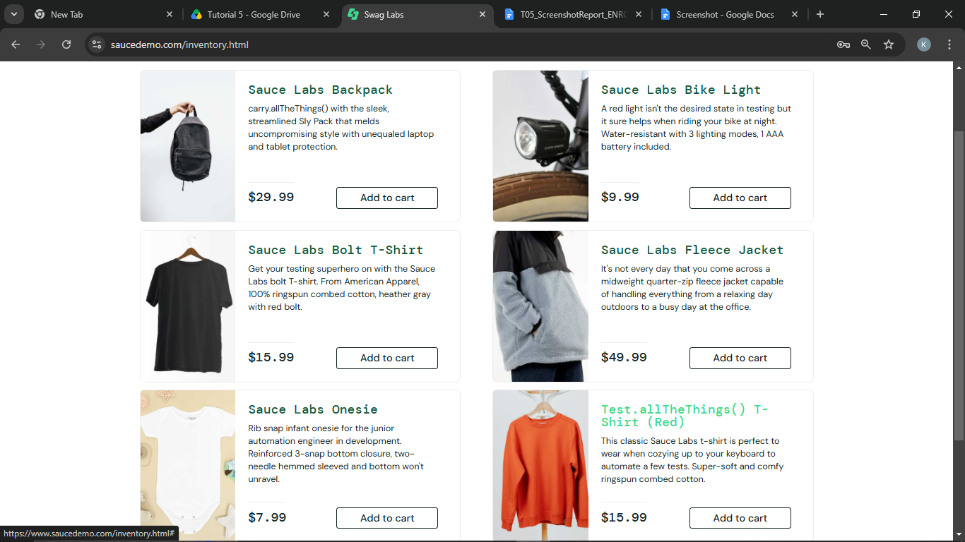
Defect ID | N/A

TC04 – Verify a product can be added to the cart
TC ID | TC04
Test Case | Verify a product can be added to the cart
Test Data | Sauce Labs Backpack
Expected Result | Button changes to 'Remove' and the cart badge shows 1
Actual Result | Button changed to Remove, badge shows 1
Status | PASS
Screenshot | 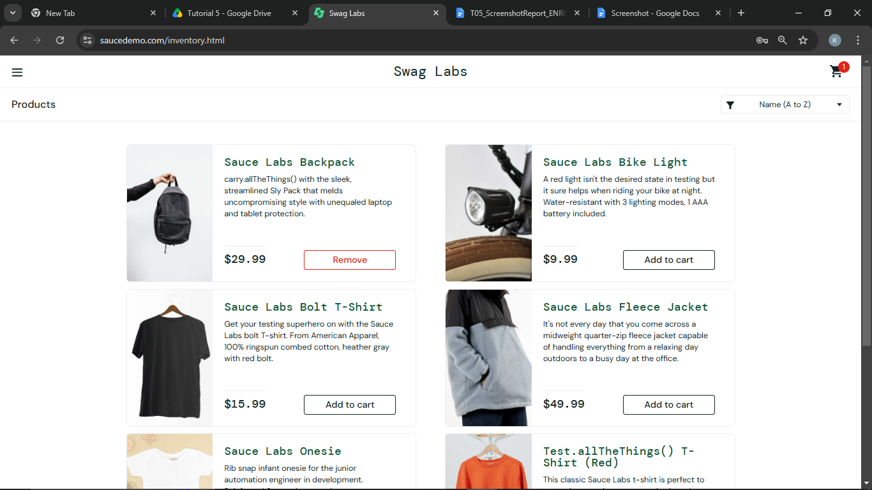
Defect ID | N/A

TC05 – Verify a product can be removed from the cart
TC ID | TC05
Test Case | Verify a product can be removed from the cart
Test Data | Sauce Labs Backpack
Expected Result | Button changes back to 'Add to cart' and the cart badge disappears
Actual Result | Item removed, badge disappeared
Status | PASS
Screenshot | 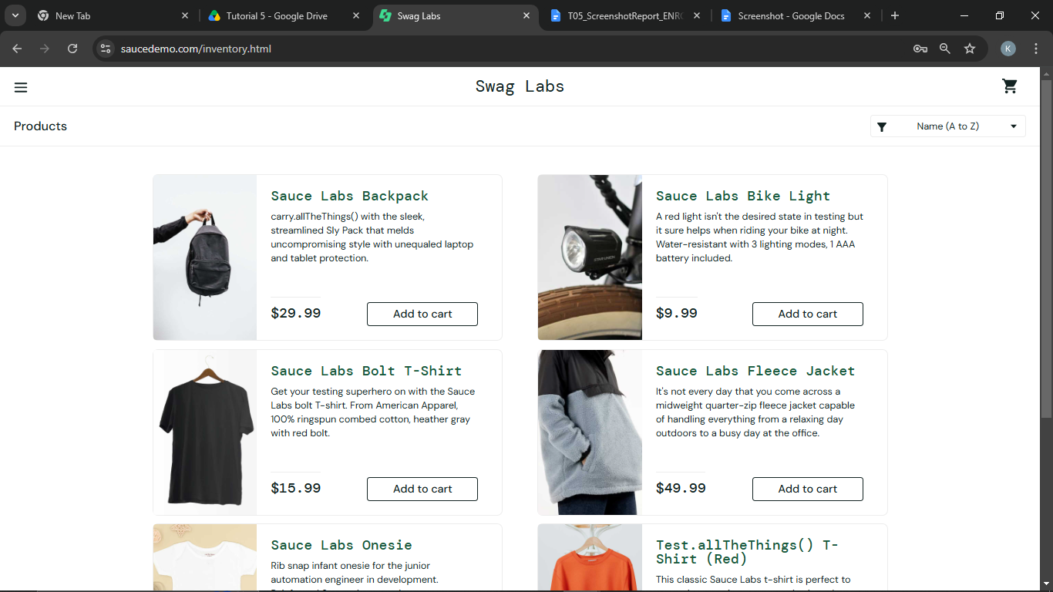
Defect ID | N/A

TC06 – Verify the cart page
TC ID | TC06
Test Case | Verify the cart page
Test Data | Sauce Labs Backpack
Expected Result | Cart lists the product with quantity 1 and its price
Actual Result | Product listed with quantity 1 and price
Status | PASS
Screenshot | 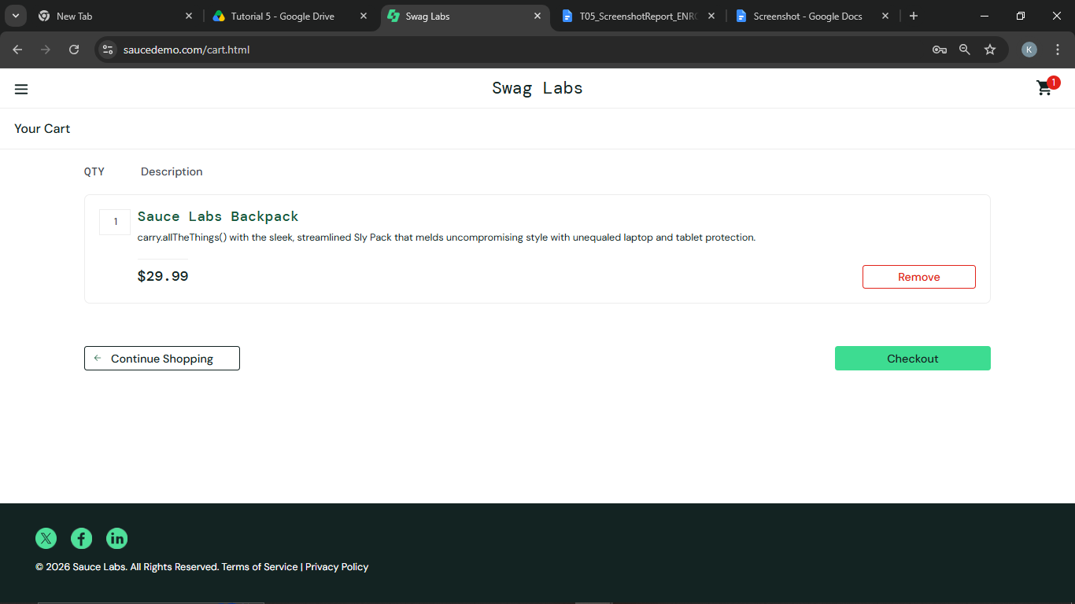
Defect ID | N/A

TC07 – Verify checkout with valid information
TC ID | TC07
Test Case | Verify checkout with valid information
Test Data | Test / User / 380001
Expected Result | Checkout: Overview page shows item, payment info, item total, tax and total
Actual Result | Overview page displayed with totals
Status | PASS
Screenshot | 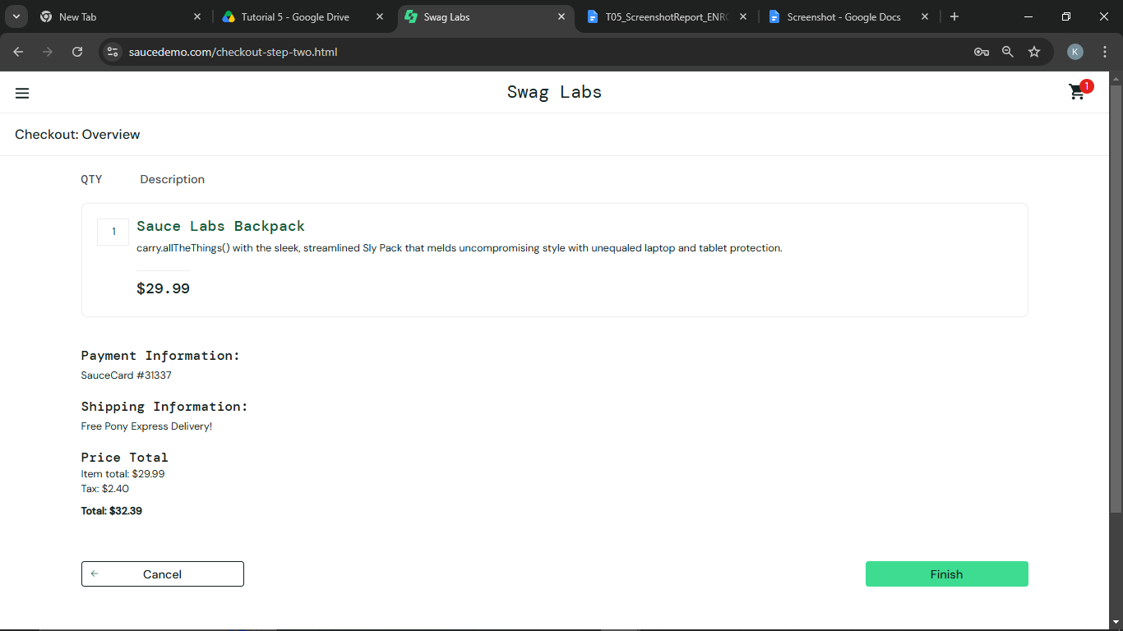
Defect ID | N/A

TC08 – Verify checkout with blank information
TC ID | TC08
Test Case | Verify checkout with blank information
Test Data | (blank)
Expected Result | Error 'Error: First Name is required' is displayed
Actual Result | Error message displayed
Status | PASS
Screenshot | 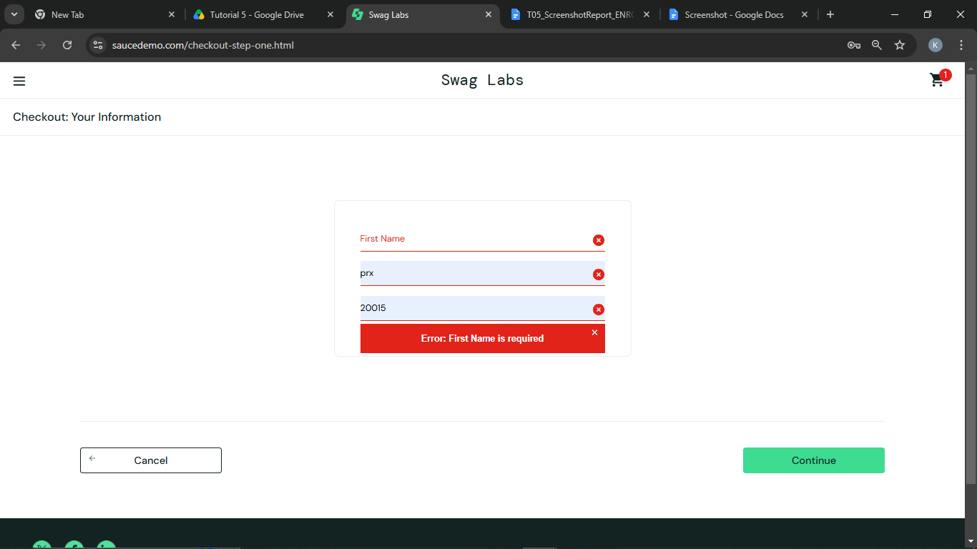
Defect ID | N/A

TC09 – Verify the order can be completed
TC ID | TC09
Test Case | Verify the order can be completed
Test Data | -
Expected Result | 'Thank you for your order!' confirmation is displayed
Actual Result | Confirmation displayed
Status | PASS
Screenshot | 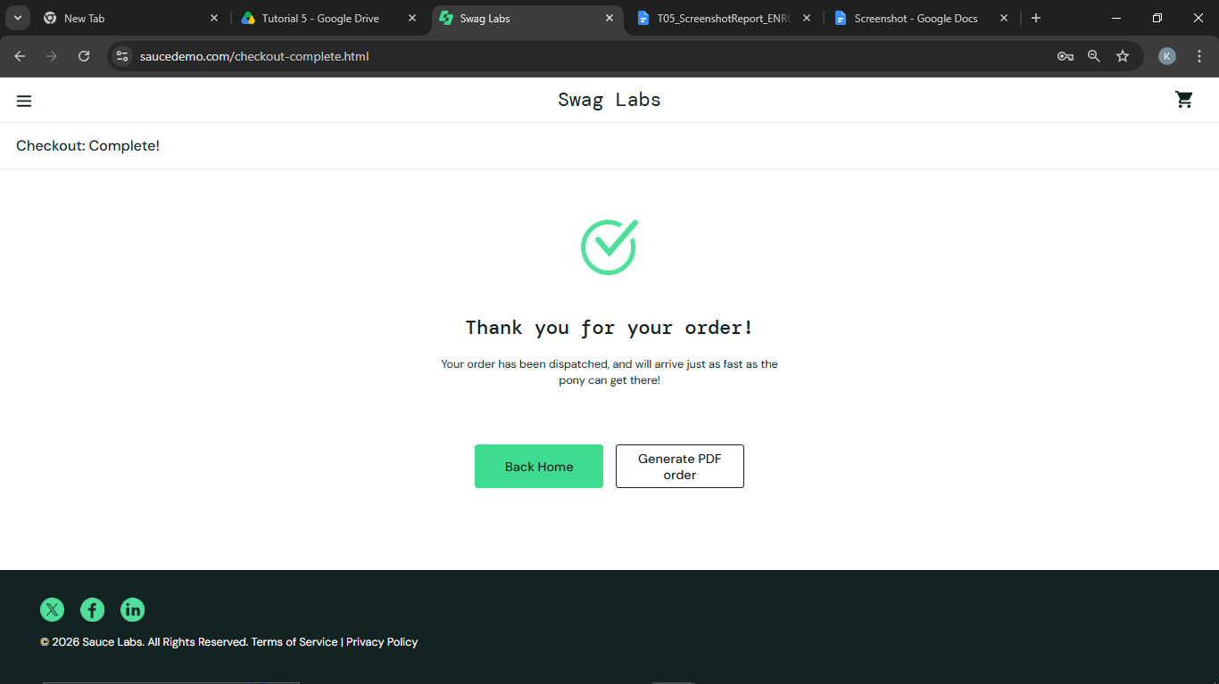
Defect ID | N/A

TC10 – Verify logout
TC ID | TC10
Test Case | Verify logout
Test Data | -
Expected Result | User is returned to the login page
Actual Result | Login page displayed
Status | PASS
Screenshot | 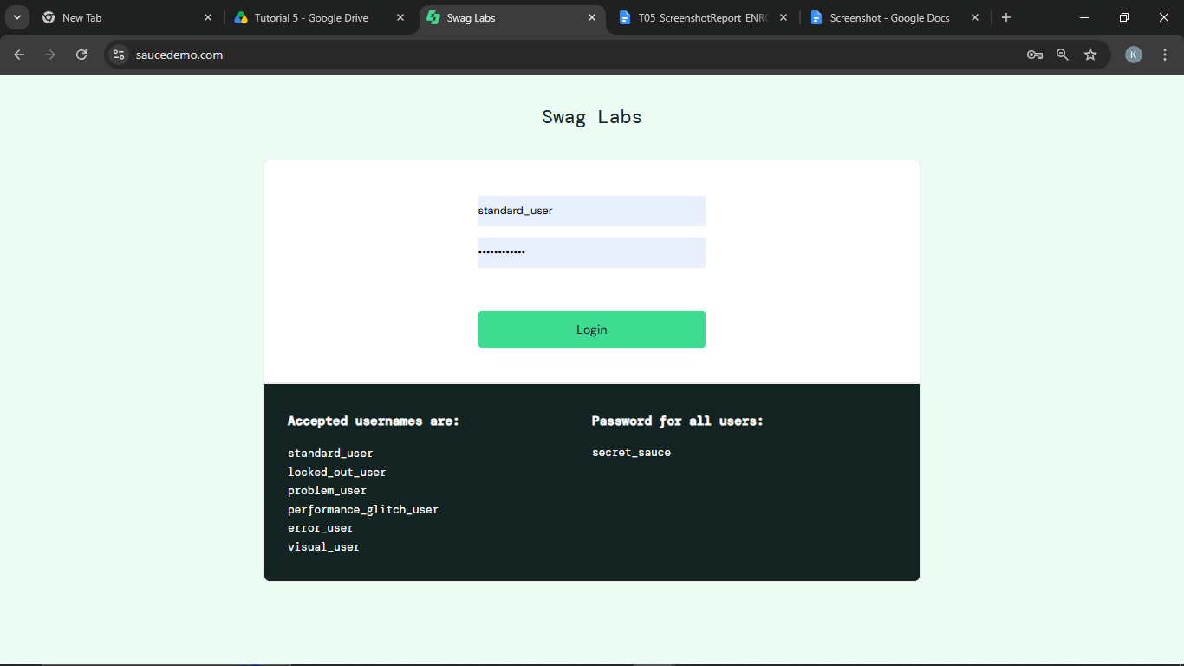
Defect ID | N/A

Defect Report (complete only if you observed a real defect)
NO defect detected

Bug Report Template - complete ONLY if you actually observe a defect
Field | Details
Bug ID | -
Bug Title | -
Module Name | -
Severity | -
Priority | -
Environment | Windows 10/11, Google Chrome, https://www.saucedemo.com
Steps to Reproduce | -
Expected Result | All steps worked perfectly
Actual Result | All steps perfect
Screenshot
Status | New
Reported By | Kothari Mann Jitendrakumar
Date Reported | -

Test Execution Summary
Metric | Value
Total Test Cases | 10
Passed | 10
Failed | 0
Blocked | 0
Not executed yet (fill after running) | 0
Pass % | 100.0%

